**​​Regression Discontinuity Study - Netflix**

Group: Yijie Fu (506310008), Guangying Pan (006309837), Wanli Chan (506308897), Zhi Zhang (306311909)

**1) What is the firm action or “treatment”, and what is the discreteness which makes it a candidate for RD analysis? Carefully explain the treatment, and what the firm’s goals are. （Lillian)**

* The treatment in this study is Netflix's offer of a one-month free trial to new users. During this period, users can access all the content available on Netflix without any cost, aiming to provide them with a complete experience of the service.
* The treatment is discrete because it is clearly defined and binary: users either receive the free trial (if they sign up before 10/2020) or they do not (if they sign up after 10/2020). This clear cutoff makes it a suitable candidate for Regression Discontinuity (RD) analysis, as there is a distinct point (the end date of the promotion) that separates treated users from non-treated users.
* The primary KPI for Netflix is the number of paying subscribers. Therefore, the primary goal of Netflix's free trial promotion is to convert trial users into paying subscribers. Network Diagram (business model)?
  + Through Network Diagram, we come up with the following hypothesis: free trail would not affect paid subscribers?

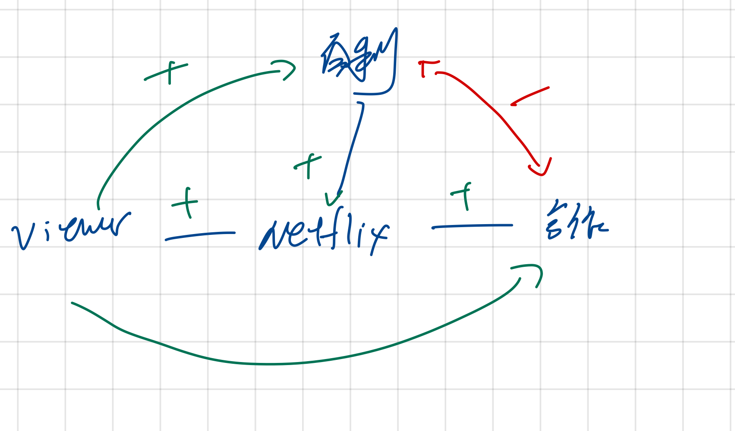

**2) What process determines who is treated and their treatment level; what would be the “running variable” in your example, and what are its cutoffs? Need to explain each variable, specifically address that subscribers mean paid customers. 他说过重点想知道怎么解释这个t (Jessy)**

* Treatment: whether provide the one-month free trial or not
* Running variable: Time
* Cutoffs: Oct, 2020

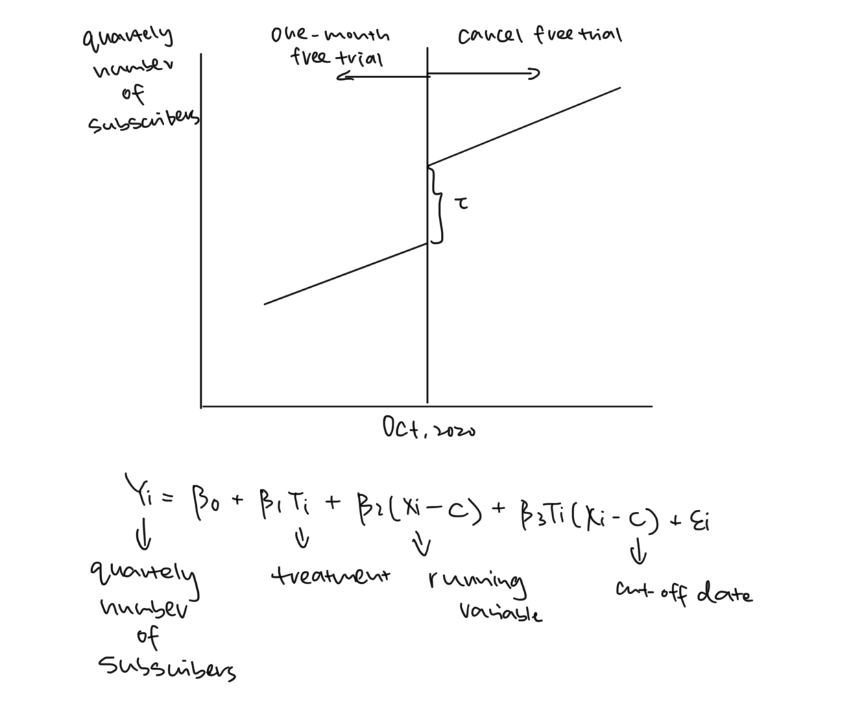

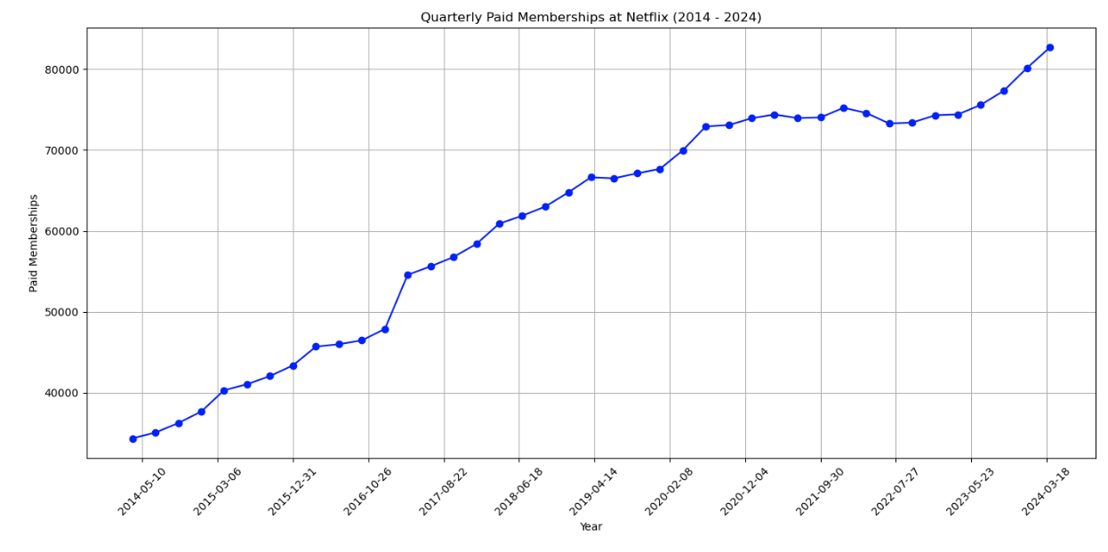

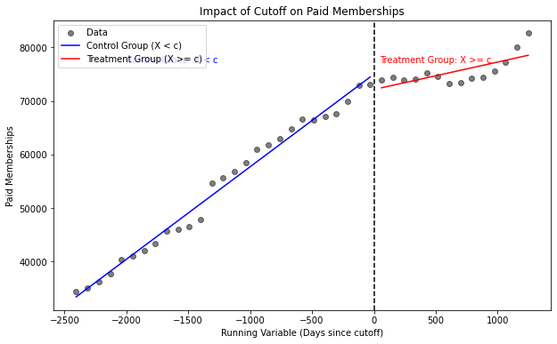

**3) What impact does the treatment have that is of most interest to the firm (and you)? Is there more than one outcome impacted by the treatment, and might these outcomes affect each other? Which effects could you measure separately, and which not? (Ceillia)**

* The primary interest is to understand how canceling the free trial impacts the quarterly number of subscribers

Other outcomes:

* Acquisition Costs: Changes in the cost of acquiring new subscribers since the free trial was previously a key acquisition tool.
* The overall impact on Netflix’s revenue, considering a potential decrease in the rate of subscriber growth and the potential increase in acquisition cost.
* All of them can’t be measured separately because they are indirectly affected by the treatment and there are other factors that would affect these outcomes, which require separate analysis

**4) Under what conditions would the RD analysis you propose be “valid”, and do you think**

**those conditions hold in your case? Are there notable “baseline covariates” that you could**

**examine to test the validity of your RD design?(Ceillia)**

* Omitted Variable Bias: The “receipt of treatment” is solely determined by the subscription date. Assuming that the effect of the subscription date on the quarterly number of subscribers is captured by a linear function, we need to be sure that no omitted variables afflicates our regression
* Conditions for Validity: The cutoff date for the free trial offer must be strictly enforced. Users signing up just before and just after the cutoff should be clearly distinguished by whether they received the free trial.
* Continuity of Running Variable: The running variable (the subscription date) should be continuous and not manipulated by the users or the firm. Users should not have the ability to choose their subscription date strategically to receive the free trial. According to this [news](https://www.theverge.com/2020/10/13/21514661/netflix-free-trial-us-cancel-content-sampling-streaming), users didn’t get any information about the termination of the free trial in advance.
* No Other Concurrent Changes: There should be no other significant changes around the cutoff date that could impact subscription rates.
* Balance of Baseline Covariates: The distribution of baseline covariates should be similar on both sides of the cutoff. This ensures that any difference in outcomes can be attributed to the treatment (free trial) and not to pre-existing differences between the groups.
  + Age: The distribution of ages of users signing up before and after the cutoff should be similar.
  + Location: The geographical distribution of users should not change abruptly at the cutoff.
  + Marketing Exposure: The extent to which users were exposed to Netflix marketing campaigns (though this might be harder to measure directly).

**5) Applying Estimates: Strategic Uses for the Firm**

* ~~这个framework 别的project 可以用？~~
* Find the **short-sided market** - elasticity of xxxx?
  + Content (grow the content team but cut the free trial → short-sided content side)
* FEINERMAN, KATE at Thu May 30, 2024 10:37amat Thu May 30, 2024 10:37am
  + Related to geographic distribution, one thing to consider is if a U.S. customer could get around the "treatment" using a VPN if Netflix continued offering free trials in other countries. Or were restrictions stricter, such as needing a credit card with an international billing address?
  + Paid subscriber 就是 completed transaction